Grayscale page
Grayscale page

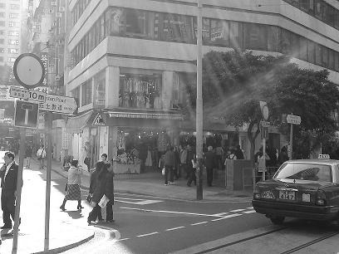

Colored page


Colored page

Grascale page

Colored page

Greyscale page

